WHAT IF Check report
This file was created 2009-05-10 from WHAT_CHECK output by a conversion script. If you are new to WHAT_CHECK, please study the pdbreport pages. There also exists a legend to the output.

Verification log for pdb2fe3.ent

Sect 0) Symmetry related problems

Note: Non crystallographic symmetry RMS plot
The plot shows the RMS differences between two similar chains on a residue-by-residue basis. Individual "spikes" can be indicative of interesting or wrong residues. If all residues show a high RMS value, the structure could be incorrectly refined.
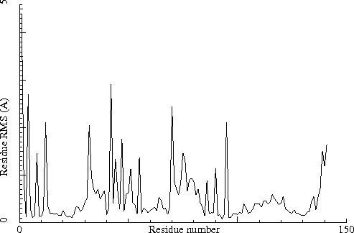
Chain identifiers of the two chains: A and B
All-atom RMS fit for the two chains : 0.835
CA-only RMS fit for the two chains : 0.412

Note: Non crystallographic symmetry backbone difference plot
The plot shows the differences in backbone torsion angles between two similar chains on a residue-by-residue basis. Individual "spikes" can be indicative of interesting or wrong residues. If all residues show high differences, the structure could be incorrectly refined.
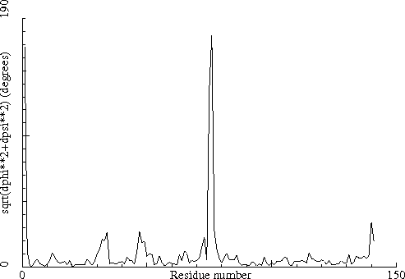
Chain identifiers of the two chains: A and B

Note: No crystallographic symmetry between molecules
No extra crystallographic symmetry was observed between the independent molecules.

Note: Matthews coefficient OK
The Matthews coefficient [REF] is defined as the density of the protein structure in cubic Angstroms per Dalton. Normal values are between 1.5 (tightly packed, little room for solvent) and 4.0 (loosely packed, much space for solvent). Some very loosely packed structures can get values a bit higher than that.
Molecular weight of all polymer chains: 32329.340
Volume of the Unit Cell V= 80056.016
Cell multiplicity: 1
Matthews coefficient for observed atoms Vm= 2.476

Sect 1) Administrative problems that can generate validation failures

Note: No strange inter-chain connections detected
No covalent bonds have been detected between molecules with non-identical chain identifiers.

Note: No duplicate atom names in ligands
All atom names in ligands seem adequately unique.

Note: No mixed usage of alternate atom problems detected
Either this structure does not contain alternate atoms, or they have not been mixed up, or the errors have remained unnoticed.

Note: In all cases the primary alternate atom was used
WHAT IF saw no need to make any alternate atom corrections (which means they are all correct, or there aren't any).

Note: No overlapping non-alternates detected
Either this structure does not contain overlapping non-alternate atoms, or they are all correct, or the errors have remained unnoticed.

Note: No residues detected inside ligands
Either this structure does not contain ligands with amino acid groups in it, or their naming is proper (enough).

Note: Ligand topologies OK
The topology could be determined for all ligands (or there are no ligands for which a topology is needed, in which case there is absolutely no problem, of course). That is good because it means that all ligands can be included in the hydrogen bond optimization and related options.

Note: No attached groups interfere with hydrogen bond calculations
It seems there are no sugars, lipids, etc., bound (very close) to atoms that otherwise could form hydrogen bonds.

Note: All residues have a complete backbone.
No residues have missing backbone atoms.

Note: No probable atoms with zero occupancy detected.
Either there are no atoms with zero occupancy, or they are not present in the file, or their positions are sufficiently improbable to warrant a zero occupancy.

Sect 2) Non-validating, descriptive output paragraph

Note: Content of the PDB file as interpreted by WHAT IF
Content of the PDB file as interpreted by WHAT IF. WHAT IF has read your PDB file, and stored it internally in what is called 'the soup'. The content of this soup is listed here. An extensive explanation of all frequently used WHAT IF output formats can be found at http://swift.cmbi.ru.nl/. Look under output formats.
1 1 ( 4) 141 ( 144) A Protein pdb2fe3.ent
2 142 ( 3) 284 ( 145) B Protein pdb2fe3.ent
3 285 ( 201) 285 ( 201) A ZN pdb2fe3.ent
4 286 ( 202) 286 ( 202) B ZN pdb2fe3.ent
5 287 ( HOH ) 287 ( HOH ) A water ( 158) pdb2fe3.ent
6 288 ( HOH ) 288 ( HOH ) B water ( 131) pdb2fe3.ent

Note: Ramachandran plot
In this Ramachandran plot x-signs represent glycines, squares represent prolines, and plus-signs represent the other residues. If too many plus-signs fall outside the contoured areas then the molecule is poorly refined (or worse). Proline can only occur in the narrow region around phi=60 that also falls within the other contour islands.
In a colour picture, the residues that are part of a helix are shown in blue, strand residues in red. "Allowed" regions for helical residues are drawn in blue, for strand residues in red, and for all other residues in green.
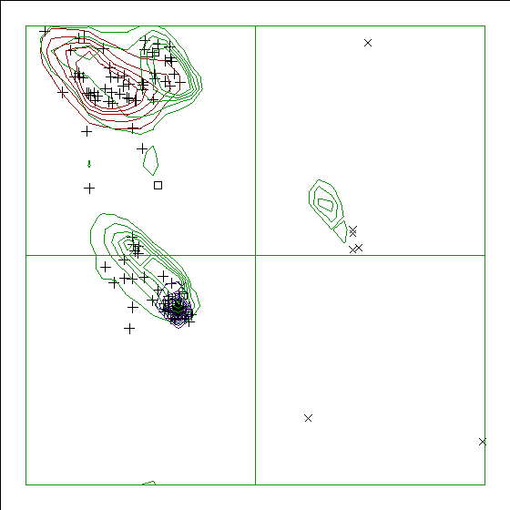
Chain identifier: A

Note: Ramachandran plot
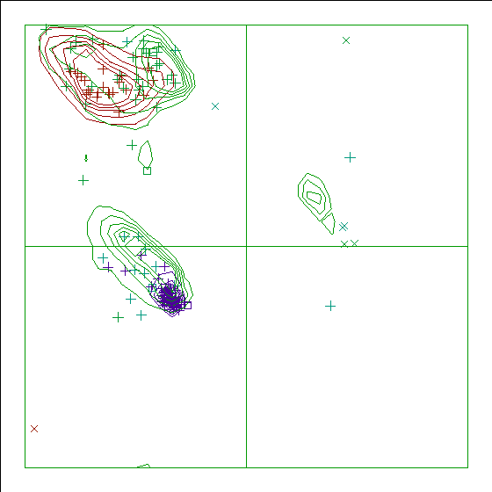
Chain identifier: B

Note: Secondary structure
This is the secondary structure according to DSSP. Only helix (H), overwound or 3/10-helix (3), strand (S), turn (T) and coil (blank) are shown. [REF]. All DSSP related information can be found at the DSSP page. This is not really a structure validation option, but a very scattered secondary structure (i.e. many strands of only a few residues length, many Ts inside helices, etc) tends to indicate a poor structure.
10 20 30 40 50 60
| | | | | |
1 - 60 HELKEALETLKETGVRITPQRHAILEYLVNSMAHPTADDIYKALEGKFPNMSVATVYNNL
( 4)-( 63) HHHHHHHHHHHTT HHHHHHHHHHHH TT HHHHHHHH333 TT HHHHHHHH
70 80 90 100 110 120
| | | | | |
61 - 120 RVFRESGLVKELTYGDASSRFDFVTSDHYHAICENCGKIVDFHYPGLDEVEQLAAHVTGF
( 64)-( 123)HHHHHTTTSSSS TTT SSSS SSSSSSTTT SSS HHHHHHHHHHH
130 140
| |
121 - 141 KVSHHRLEIYGVCQECSKKEN
( 124)-( 144) SSSSSS HHHHHHH

150 160 170 180 190 200
| | | | | |
142 - 201 AHELKEALETLKETGVRITPQRHAILEYLVNSMAHPTADDIYKALEGKFPNMSVATVYNN
( 3)-( 62) HHHHHHHHHHHHTT HHHHHHHHHHHH TT HHHHHHHHTTT TT HHHHHHH
210 220 230 240 250 260
| | | | | |
202 - 261 LRVFRESGLVKELTYGDASSRFDFVTSDHYHAICENCGKIVDFHYPGLDEVEQLAAHVTG
( 63)-( 122)HHHHHHTTTSSSS TTT SSSS SSSSSSTTT SSS HHHHHHHHHHH
270 280
| |
262 - 284 FKVSHHRLEIYGVCQECSKKENH
( 123)-( 145) SSSSSS HHHHHHHT

Sect 3) Coordinate problems, unexpected atoms, B-factor and occupancy checks

Note: No rounded coordinates detected
No significant rounding of atom coordinates has been detected.

Note: No artificial side chains detected
No artificial side-chain positions characterized by chi-1=0.00 or chi-1=180.00 have been detected.

Warning: Missing atoms
The atoms listed in the table below are missing from the entry. If many atoms are missing, the other checks can become less sensitive. Be aware that it often happens that groups at the termini of DNA or RNA are really missing, so that the absence of these atoms normally is neither an error nor the result of poor electron density. Some of the atoms listed here might also be listed by other checks.
284 HIS ( 145-) B - CB
284 HIS ( 145-) B - CG
284 HIS ( 145-) B - ND1
284 HIS ( 145-) B - CD2
284 HIS ( 145-) B - CE1
284 HIS ( 145-) B - NE2

Note: No C-terminal nitrogen detected
It is becoming habit to indicate that a residue is not the true C-terminus by including only the backbone N of the next residue. This has not been observed in this PDB file.

Note: Test capping of (pseudo) C-termini
No extra capping groups were found on pseudo C-termini. This can imply that no pseudo C-termini are present.

Error: C-terminal group missing
The residues listed below are true C-terminal groups that are missing a C-terminal capping group (OXT, post-translational modification, or backbone N of next residue)
141 ASN ( 144-) A -
284 HIS ( 145-) B -

Note: No OXT found in the middle of chains
No C-terminal OXT groups were found in the middle of protein chains.

Note: Weights checked OK
All atomic occupancy factors ('weights') fall in the 0.0--1.0 range.

Note: Normal distribution of occupancy values
The distribution of the occupancy values in this file seems 'normal'.
Be aware that this evaluation is merely the result of comparing this file with about 500 well-refined high-resolution files in the PDB. If this file has much higher or much lower resolution than the PDB files used in WHAT IF's trainig set, non-normal values might very well be perfectly fine, or normal values might actually be not so normal. So, this check is actually more an indicator and certainly not a check in which I have great confidence.

Warning: Occupancies atoms do not add up to 1.0.
In principle, the occupancy of all alternates of one atom should add up till 1.0. A valid exception is the missing atom (i.e. an atom not seen in the electron density) that is allowed to have a 0.0 occupancy. Sometimes this even happens when there are no alternate atoms given...
Atoms want to move. That is the direct result of the second law of thermodynamics, in a somewhat weird way of thinking. Any way, many atoms seem to have more than one position where they like to sit, and they jump between them. The population difference between those sites (which is related to their energy differences) is seen in the occupancy factors. As also for atoms it is 'to be or not to be', these occupancies should add up to 1.0. And the residues listed below contain atoms that have an occupancy greater than zero, but all their alternates don't add up to one.
WARNING. Presently WHAT IF only deals with a maximum of two alternate positions. A small number of atoms in the PDB has three alternates. In those cases the warning given here should obviously be neglected! In the next release we will fix this.
4 LYS ( 7-) A -
26 GLU ( 29-) A -
108 ASP ( 111-) A -
146 LYS ( 7-) B -
168 GLU ( 29-) B -
250 ASP ( 111-) B -

Note: Average B-factor OK
The average B-factor of buried atoms is within expected values for a room-temperature X-ray study.
Average B-factor for buried atoms : 20.321

Note: Number of buried atoms with low B-factor is OK
For protein structures determined at room temperature, no more than about 1 percent of the B factors of buried atoms is below 5.0.
Percentage of buried atoms with B less than 5 : 0.00

Note: B-factor distribution normal
The distribution of B-factors within residues is within expected ranges. A value over 1.5 here would mean that the B-factors show signs of over-refinement.
RMS Z-score : 0.477 over 2029 bonds
Average difference in B over a bond : 1.26
RMS difference in B over a bond : 1.83

Note: B-factor plot
The average atomic B-factor per residue is plotted as function of the residue number.
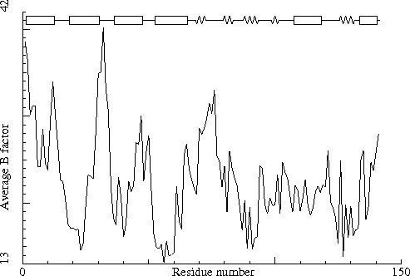
Chain identifier: A

Note: B-factor plot
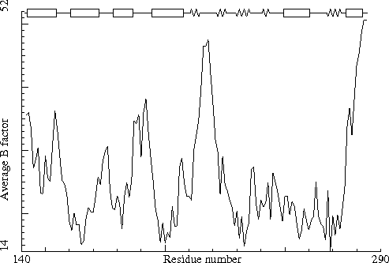
Chain identifier: B

Sect 4) Nomenclature related problems

Note: Valine nomenclature OK
No errors were detected in valine nomenclature.

Note: Threonine nomenclature OK
No errors were detected in threonine nomenclature.

Note: Isoleucine nomenclature OK
No errors were detected in isoleucine nomenclature.

Note: Leucine nomenclature OK
No errors were detected in leucine nomenclature.

Warning: Arginine nomenclature problem
The arginine residues listed in the table below have their N-H-1 and N-H-2 swapped.
64 ARG ( 67-) A -

Warning: Tyrosine convention problem
The tyrosine residues listed in the table below have their chi-2 not between -90.0 and 90.0
41 TYR ( 44-) A -
57 TYR ( 60-) A -
89 TYR ( 92-) A -
130 TYR ( 133-) A -
183 TYR ( 44-) B -
199 TYR ( 60-) B -
272 TYR ( 133-) B -

Warning: Phenylalanine convention problem
The phenylalanine residues listed in the table below have their chi-2 not between -90.0 and 90.0.
102 PHE ( 105-) A -
244 PHE ( 105-) B -

Note: Aspartic acid torsion conventions OK
No errors were detected in aspartic acid torsion angle conventions.

Warning: Glutamic acid convention problem
The glutamic acid residues listed in the table below have their chi-3 outside the -90.0 to 90.0 range, or their proton on OE1 instead of OE2.
94 GLU ( 97-) A -

Note: Phosphate group names OK
No errors were detected in phosphate group naming conventions.

Note: Heavy atom naming OK
No errors were detected in the atom names for non-hydrogen atoms. Please be aware that the PDB wants us to deliberately make some nomenclature errors; especially in non-canonical amino acids.

Note: Chain names are OK
All chain names assigned to polymer molecules are unique, and all residue numbers are strictly increasing within each chain.

Sect 5) Geometric checks

Note: All bond lengths OK
All bond lengths are in agreement with standard bond lengths using a tolerance of 4 sigma (both standard values and sigma for amino acid residues have been taken from Engh and Huber [REF], for DNA/RNA from Parkinson et al [REF])

Warning: Low bond length variability
Bond lengths were found to deviate less than normal from the mean Engh and Huber [REF] and/or Parkinson et al [REF] standard bond lengths. The RMS Z-score given below is expected to be around 1.0 for a normally restrained data set. The fact that it is lower than 0.667 in this structure might indicate that too-strong constraints have been used in the refinement. This can only be a problem for high resolution X-ray structures.
RMS Z-score for bond lengths: 0.536
RMS-deviation in bond distances: 0.013

Warning: Possible cell scaling problem
Comparison of bond distances with Engh and Huber [REF] standard values for protein residues and Parkinson et al [REF] values for DNA/RNA shows a significant systematic deviation. It could be that the unit cell used in refinement was not accurate enough. The deformation matrix given below gives the deviations found: the three numbers on the diagonal represent the relative corrections needed along the A, B and C cell axis. These values are 1.000 in a normal case, but have significant deviations here (significant at the 99.99 percent confidence level)
There are a number of different possible causes for the discrepancy. First the cell used in refinement can be different from the best cell calculated. Second, the value of lambda used for a synchrotron data set can be miscalibrated. Finally, the discrepancy can be caused by a dataset that has not been corrected for significant anisotropic thermal motion.
Please note that the proposed scale matrix has NOT been constrained to obey the space group symmetry. This is done on purpose. The distortions can give you an indication of the accuracy of the determination.
If you intend to use the result of this check to change the cell dimension of your crystal, please read the extensive literature on this topic first. This check depends on the wavelength, the cell dimensions, and on the standard bond lengths and bond angles used by your refinement software.
Unit Cell deformation matrix
| 0.997392 0.000672 0.000376|
| 0.000672 0.996733 -0.000451|
| 0.000376 -0.000451 0.996366|
Proposed new scale matrix
| 0.024294 -0.013512 -0.003438|
| -0.000018 0.027218 -0.001654|
| -0.000007 0.000009 0.019079|
With corresponding cell
A = 41.181 B = 42.055 C = 53.310
Alpha= 82.189 Beta= 80.048 Gamma= 60.880
The CRYST1 cell dimensions
A = 41.290 B = 42.160 C = 53.490
Alpha= 82.180 Beta= 80.110 Gamma= 60.960
Variance: 101.242
(Under-)estimated Z-score: 7.416

Warning: Unusual bond angles
The bond angles listed in the table below were found to deviate more than 4 sigma from standard bond angles (both standard values and sigma for protein residues have been taken from Engh and Huber [REF], for DNA/RNA from Parkinson et al [REF]). In the table below for each strange angle the bond angle and the number of standard deviations it differs from the standard values is given. Please note that disulphide bridges are neglected. Atoms starting with "-" belong to the previous residue in the sequence.
55 THR ( 58-) A - N CA CB 102.16 -4.9
55 THR ( 58-) A - C CA CB 118.16 4.2
55 THR ( 58-) A - CG2 CB OG1 119.30 5.0
232 HIS ( 93-) B - CG ND1 CE1 109.60 4.0

Note: Normal bond angle variability
Bond angles were found to deviate normally from the mean standard bond angles (normal values for protein residues were taken from Engh and Huber [REF], for DNA/RNA from Parkinson et al [REF]). The RMS Z-score given below is expected to be around 1.0 for a normally restrained data set, and this is indeed observed for very high resolution X-ray structures. More common values are around 1.55.
RMS Z-score for bond angles: 0.717
RMS-deviation in bond angles: 1.328

Error: Nomenclature error(s)
You are asking for a hand-check. WHAT IF has over the course of this session already corrected the handedness of atoms in several residues. These residues are listed here.
64 ARG ( 67-) A -
94 GLU ( 97-) A -

Warning: Chirality deviations detected
The atoms listed in the table below have an improper dihedral value that is deviating from expected values. As the improper dihedral values are all getting very close to ideal values in recent X-ray structures, and as we actually don't know how big the spread around these values should be, this check only warns for 6 sigma deviations.
Improper dihedrals are a measure of the chirality/planarity of the structure at a specific atom. Values around -35 or +35 are expected for chiral atoms, and values around 0 for planar atoms. Planar side chains are left out of the calculations, these are better handled by the planarity checks.
Three numbers are given for each atom in the table. The first is the Z-score for the improper dihedral. The second number is the measured improper dihedral. The third number is the expected value for this atom type. A final column contains an extra warning if the chirality for an atom is opposite to the expected value.
55 THR ( 58-) A - CB -6.1 20.36 34.10

Note: Improper dihedral angle distribution OK
The RMS Z-score for all improper dihedrals in the structure is within normal ranges.
Improper dihedral RMS Z-score : 0.723

Note: Side chain planarity OK
All of the side chains of residues that have a planar group are planar within expected RMS deviations.

Note: Atoms connected to aromatic rings OK
All of the atoms that are connected to planar aromatic rings in side chains of amino-acid residues are in the plane within expected RMS deviations.

Sect 6) Torsion-related checks

Note: PRO puckering amplitude OK
Puckering amplitudes for all PRO residues are within normal ranges.

Warning: Unusual PRO puckering phases
The proline residues listed in the table below have a puckering phase that is not expected to occur in protein structures. Puckering parameters were calculated by the method of Cremer and Pople [REF]. Normal PRO rings approximately show a so-called envelope conformation with the C-gamma atom above the plane of the ring (phi=+72 degrees), or a half-chair conformation with C-gamma below and C-beta above the plane of the ring (phi=-90 degrees). If phi deviates strongly from these values, this is indicative of a very strange conformation for a PRO residue, and definitely requires a manual check of the data. Be aware that this is a warning with a low confidence level. See: Who checks the checkers? Four validation tools applied to eight atomic resolution structures. K.Wilson, C.Sander, R.W.W.Hooft, G.Vriend, et al. J.Mol.Biol. (1998) 276,417-436.
191 PRO ( 52-) B - 51.8 half-chair C-delta/C-gamma (54 degrees)

Warning: Torsion angle evaluation shows unusual residues
The residues listed in the table below contain bad or abnormal torsion angles.
These scores give an impression of how `normal' the torsion angles in protein residues are. All torsion angles except omega are used for calculating a `normality' score. Average values and standard deviations were obtained from the residues in the WHAT IF database. These are used to calculate Z-scores. A residue with a Z-score of below -2.0 is poor, and a score of less than -3.0 is worrying. For such residues more than one torsion angle is in a highly unlikely position.
217 GLY ( 78-) B - -2.3
47 LYS ( 50-) A - -2.2
75 GLY ( 78-) A - -2.1
186 LEU ( 47-) B - -2.0

Warning: Backbone torsion angle evaluation shows unusual conformations
The residues listed in the table below have abnormal backbone torsion angles.
Residues with `forbidden' phi-psi combinations are listed, as well as residues with unusual omega angles (deviating by more than 3 sigma from the normal value). Please note that it is normal if about 5 percent of the residues is listed here as having unusual phi-psi combinations.
75 GLY ( 78-) A - Poor phi/psi
105 PRO ( 108-) A - Poor phi/psi
120 PHE ( 123-) A - omega poor
217 GLY ( 78-) B - Poor phi/psi
218 ASP ( 79-) B - Poor phi/psi
247 PRO ( 108-) B - Poor phi/psi
262 PHE ( 123-) B - omega poor
283 ASN ( 144-) B - Poor phi/psi

Note: Ramachandran Z-score OK
The score expressing how well the backbone conformations of all residues are corresponding to the known allowed areas in the Ramachandran plot is within expected ranges for well-refined structures.
Ramachandran Z-score : 1.723

Note: Omega angle restraint OK
The omega angles for trans-peptide bonds in a structure is expected to give a gaussian distribution with the average around +178 degrees, and a standard deviation around 5.5. In the current structure the standard deviation agrees with this expectation.
Standard deviation of omega values : 0.986

Note: chi-1/chi-2 angle correlation Z-score OK
The score expressing how well the chi-1/chi-2 angles of all residues are corresponding to the populated areas in the database is within expected ranges for well-refined structures.
chi-1/chi-2 correlation Z-score : 0.204

Note: Backbone oxygen evaluation OK
All residues for which the local backbone conformation could be found in the WHAT IF database have a normal backbone oxygen position.

Note: Rotamers checked OK
None of the residues that have a normal backbone environment have abnormal rotamers.

Warning: Unusual backbone conformations
For the residues listed in the table below, the backbone formed by itself and two neighboring residues on either side is in a conformation that is not seen very often in the database of solved protein structures. The number given in the table is the number of similar backbone conformations in the database with the same amino acid in the center.
For this check, backbone conformations are compared with database structures using C-alpha superpositions with some restraints on the backbone oxygen positions.
A residue mentioned in the table can be part of a strange loop, or there might be something wrong with it or its directly surrounding residues. There are a few of these in every protein, but in any case it is worth looking at!
74 TYR ( 77-) A - 0
105 PRO ( 108-) A - 0
124 HIS ( 127-) A - 0
140 GLU ( 143-) A - 0
141 ASN ( 144-) A - 0
142 ALA ( 3-) B - 0
143 HIS ( 4-) B - 0
218 ASP ( 79-) B - 0
247 PRO ( 108-) B - 0
266 HIS ( 127-) B - 0

Note: Backbone conformation Z-score OK
The backbone conformation analysis gives a score that is normal for well refined protein structures.
Backbone conformation Z-score : 1.603

Sect 7) Bump checks

Error: Abnormally short interatomic distances
The pairs of atoms listed in the table below have an unusually short distance.
The contact distances of all atom pairs have been checked. Two atoms are said to `bump' if they are closer than the sum of their Van der Waals radii minus 0.40 Angstrom. For hydrogen bonded pairs a tolerance of 0.55 Angstrom is used. The first number in the table tells you how much shorter that specific contact is than the acceptable limit. The second distance is the distance between the centers of the two atoms. Although we believe that two water atoms at 2.4 A distance are too close, we only report water pairs that are closer than this rather short distance.
The last text-item on each line represents the status of the atom pair. The text `INTRA' means that the bump is between atoms that are explicitly listed in the PDB file. `INTER' means it is an inter-symmetry bump. If the final column contains the text 'HB', the bump criterium was relaxed because there could be a hydrogen bond. Similarly relaxed criteria are used for 1--3 and 1--4 interactions (listed as 'B2' and 'B3', respectively). If the last column is 'BF', the sum of the B-factors of the atoms is higher than 80, which makes the appearance of the bump somewhat less severe because the atoms probably aren't there anyway.
Bumps between atoms for which the sum of their occupancies is lower than one are not reported. In any case, each bump is listed in only one direction. If the MODEL number doesn't exist (like in most X-ray files), an underscore is printed instead.
20 GLN ( 23-) A - NE2 <--> 55 THR ( 58-) A - CG2 0.64 2.46 INTRA
108 ASP ( 111-) A - OD1 <--> 287 HOH ( 339 ) A - O 0.59 1.81 INTRA
288 HOH ( 330 ) B - O <--> 288 HOH ( 331 ) B - O 0.30 1.90 INTRA
90 HIS ( 93-) A - CD2 <--> 101 ASP ( 104-) A - OD1 0.29 2.51 INTRA
245 HIS ( 106-) B - NE2 <--> 288 HOH ( 293 ) B - O 0.26 2.44 INTRA
153 LYS ( 14-) B - NZ <--> 288 HOH ( 212 ) B - O 0.23 2.47 INTRA
34 HIS ( 37-) A - CD2 <--> 72 LEU ( 75-) A - CD1 0.20 3.00 INTRA
139 LYS ( 142-) A - NZ <--> 287 HOH ( 294 ) A - O 0.17 2.53 INTRA
103 HIS ( 106-) A - NE2 <--> 287 HOH ( 274 ) A - O 0.17 2.53 INTRA
254 GLN ( 115-) B - NE2 <--> 288 HOH ( 209 ) B - O 0.17 2.53 INTRA
232 HIS ( 93-) B - ND1 <--> 243 ASP ( 104-) B - OD1 0.16 2.54 INTRA
126 ARG ( 129-) A - NH1 <--> 268 ARG ( 129-) B - NH1 0.14 2.71 INTRA
250 ASP ( 111-) B - OD1 <--> 288 HOH ( 318 ) B - O 0.14 2.26 INTRA
112 GLN ( 115-) A - NE2 <--> 287 HOH ( 208 ) A - O 0.12 2.58 INTRA
95 ASN ( 98-) A - ND2 <--> 140 GLU ( 143-) A - OE2 0.12 2.58 INTRA
287 HOH ( 266 ) A - O <--> 288 HOH ( 332 ) B - O 0.12 2.28 INTRA
176 HIS ( 37-) B - CD2 <--> 214 LEU ( 75-) B - CD1 0.09 3.11 INTRA
21 ARG ( 24-) A - NE <--> 59 ASN ( 62-) A - ND2 0.09 2.76 INTRA
141 ASN ( 144-) A - O <--> 287 HOH ( 358 ) A - O 0.08 2.32 INTRA
121 LYS ( 124-) A - NZ <--> 284 HIS ( 145-) B - O 0.08 2.62 INTRA BF
85 THR ( 88-) A - O <--> 287 HOH ( 251 ) A - O 0.08 2.32 INTRA
126 ARG ( 129-) A - NH1 <--> 270 GLU ( 131-) B - OE1 0.08 2.62 INTRA
128 GLU ( 131-) A - OE1 <--> 130 TYR ( 133-) A - OH 0.05 2.35 INTRA
20 GLN ( 23-) A - CD <--> 55 THR ( 58-) A - CG2 0.05 3.15 INTRA
287 HOH ( 358 ) A - O <--> 288 HOH ( 332 ) B - O 0.04 2.36 INTRA BF
287 HOH ( 219 ) A - O <--> 287 HOH ( 315 ) A - O 0.04 2.16 INTRA
253 GLU ( 114-) B - OE2 <--> 267 HIS ( 128-) B - ND1 0.03 2.67 INTRA
217 GLY ( 78-) B - O <--> 219 ALA ( 80-) B - N 0.03 2.67 INTRA BF
11 LYS ( 14-) A - NZ <--> 287 HOH ( 216 ) A - O 0.02 2.68 INTRA
235 CYS ( 96-) B - SG <--> 275 CYS ( 136-) B - N 0.02 3.28 INTRA
27 TYR ( 30-) A - OH <--> 287 HOH ( 238 ) A - O 0.02 2.38 INTRA
164 HIS ( 25-) B - ND1 <--> 288 HOH ( 220 ) B - O 0.01 2.69 INTRA
46 GLY ( 49-) A - N <--> 287 HOH ( 227 ) A - O 0.01 2.69 INTRA
201 ASN ( 62-) B - ND2 <--> 288 HOH ( 229 ) B - O 0.00 2.70 INTRA
240 LYS ( 101-) B - NZ <--> 288 HOH ( 266 ) B - O 0.00 2.70 INTRA

Sect 8) Packing, accessibility and threading

Note: Inside/Outside residue distribution normal
The distribution of residue types over the inside and the outside of the protein is normal.
inside/outside RMS Z-score : 0.941

Note: Inside/Outside RMS Z-score plot
The Inside/Outside distribution normality RMS Z-score over a 15 residue window is plotted as function of the residue number. High areas in the plot (above 1.5) indicate unusual inside/outside patterns.
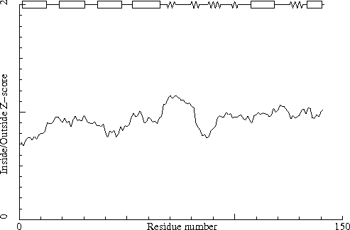
Chain identifier: A

Note: Inside/Outside RMS Z-score plot
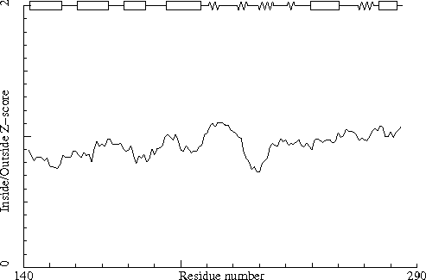
Chain identifier: B

Warning: Abnormal packing environment for some residues
The residues listed in the table below have an unusual packing environment.
The packing environment of the residues is compared with the average packing environment for all residues of the same type in good PDB files. A low packing score can indicate one of several things: Poor packing, misthreading of the sequence through the density, crystal contacts, contacts with a co-factor, or the residue is part of the active site. It is not uncommon to see a few of these, but in any case this requires further inspection of the residue.
245 HIS ( 106-) B - -6.16
103 HIS ( 106-) A - -6.05
74 TYR ( 77-) A - -5.81
216 TYR ( 77-) B - -5.69
174 MET ( 35-) B - -5.63
32 MET ( 35-) A - -5.61
30 ASN ( 33-) A - -5.21
172 ASN ( 33-) B - -5.18
283 ASN ( 144-) B - -5.10
140 GLU ( 143-) A - -5.01

Note: No series of residues with bad packing environment
There are no stretches of three or more residues each having a quality control score worse than -4.0.

Note: Structural average packing environment OK
The structural average quality control value is within normal ranges.
Average for range 1 - 284 : -0.206

Note: Quality value plot
The quality value smoothed over a 10 residue window is plotted as function of the residue number. Low areas in the plot (below -2.0) indicate "unusual" packing.
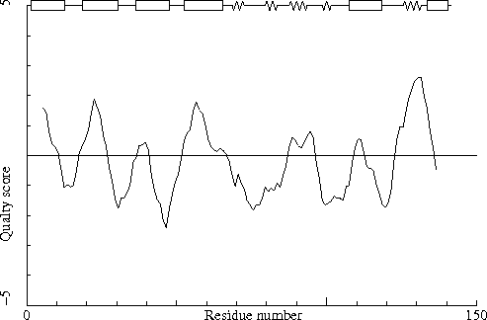
Chain identifier: A

Note: Quality value plot
The quality value smoothed over a 10 residue window is plotted as function of the residue number. Low areas in the plot (below -2.0) indicate "unusual" packing.
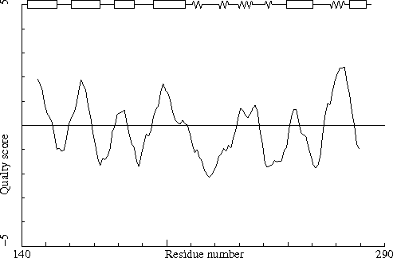
Chain identifier: B

Warning: Low packing Z-score for some residues
The residues listed in the table below have an unusual packing environment according to the 2nd generation quality check. The score listed in the table is a packing normality Z-score: positive means better than average, negative means worse than average. Only residues scoring less than -2.50 are listed here. These are the "unusual" residues in the structure, so it will be interesting to take a special look at them.
284 HIS ( 145-) B - -3.75
245 HIS ( 106-) B - -2.51

Note: No series of residues with abnormal new packing environment
There are no stretches of four or more residues each having a quality control Z-score worse than -1.75.

Note: Structural average packing Z-score OK
The structural average for the second generation quality control value is within normal ranges.
All contacts : Average = -0.029 Z-score = -0.22
BB-BB contacts : Average = 0.090 Z-score = 0.48
BB-SC contacts : Average = -0.032 Z-score = -0.25
SC-BB contacts : Average = -0.029 Z-score = -0.12
SC-SC contacts : Average = -0.246 Z-score = -1.48

Note: Second generation quality Z-score plot
The second generation quality Z-score smoothed over a 10 residue window is plotted as function of the residue number. Low areas in the plot (below -1.3) indicate "unusual" packing.
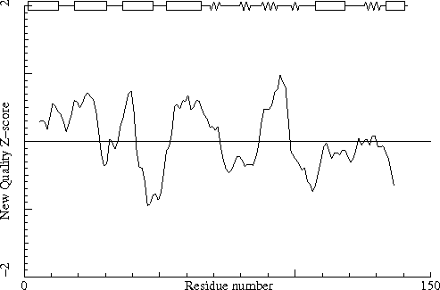
Chain identifier: A

Note: Second generation quality Z-score plot
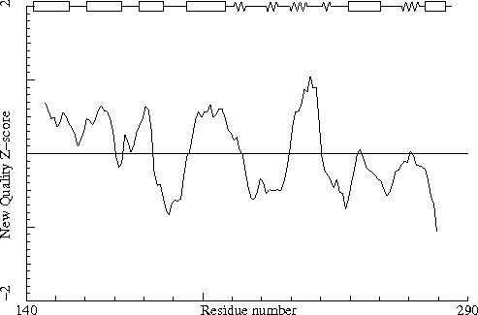
Chain identifier: B

Sect 9) Water and hydrogenbond related checks

Note: Water contacts OK
All water clusters make at least one contact with a non-water atom.

Warning: Water molecules need moving
The water molecules listed in the table below were found to be significantly closer to a symmetry related non-water molecule than to the ones given in the coordinate file. For optimal viewing convenience revised coordinates for these water molecules should be given.
The number in brackets is the identifier of the water molecule in the input file. Suggested coordinates are also given in the table. Please note that alternative conformations for protein residues are not taken into account for this calculation. If you are using WHAT IF / WHAT-CHECK interactively, then the moved waters can be found in PDB format in the file: MOVED-H2O.pdb.
287 HOH ( 322 ) A - O -3.15 -36.59 -58.90
287 HOH ( 323 ) A - O -5.48 -36.78 -56.48
287 HOH ( 325 ) A - O -14.47 4.96 -9.74
287 HOH ( 330 ) A - O -3.97 -40.55 -53.47
287 HOH ( 333 ) A - O -9.33 -32.93 -38.99
287 HOH ( 338 ) A - O -3.52 -36.32 -40.45
287 HOH ( 349 ) A - O 4.50 -40.78 -37.23
287 HOH ( 351 ) A - O -0.91 -41.40 -54.14
288 HOH ( 313 ) B - O -10.11 14.31 -12.93
288 HOH ( 315 ) B - O 17.83 19.93 -32.89
288 HOH ( 322 ) B - O 3.00 18.94 -39.27
288 HOH ( 333 ) B - O 15.67 23.34 -18.81

Error: Water molecules without hydrogen bonds
The water molecules listed in the table below do not form any hydrogen bonds, neither with the protein or DNA/RNA, nor with other water molecules. This is a strong indication of a refinement problem. The last number on each line is the identifier of the water molecule in the input file.
287 HOH ( 344 ) A - O
288 HOH ( 269 ) B - O
288 HOH ( 312 ) B - O
288 HOH ( 329 ) B - O

Error: HIS, ASN, GLN side chain flips
Listed here are Histidine, Asparagine or Glutamine residues for which the orientation determined from hydrogen bonding analysis are different from the assignment given in the input. Either they could form energetically more favorable hydrogen bonds if the terminal group was rotated by 180 degrees, or there is no assignment in the input file (atom type 'A') but an assignment could be made. Be aware, though, that if the topology could not be determined for one or more ligands, then this option will make errors.
58 ASN ( 61-) A -
59 ASN ( 62-) A -
90 HIS ( 93-) A -
112 GLN ( 115-) A -
116 HIS ( 119-) A -
176 HIS ( 37-) B -
200 ASN ( 61-) B -
201 ASN ( 62-) B -
254 GLN ( 115-) B -
258 HIS ( 119-) B -

Note: Histidine type assignments
For all complete HIS residues in the structure a tentative assignment to HIS-D (protonated on ND1), HIS-E (protonated on NE2), or HIS-H (protonated on both ND1 and NE2, positively charged) is made based on the hydrogen bond network. A second assignment is made based on which of the Engh and Huber [REF] histidine geometries fits best to the structure.
In the table below all normal histidine residues are listed. The assignment based on the geometry of the residue is listed first, together with the RMS Z-score for the fit to the Engh and Huber parameters. For all residues where the H-bond assignment is different, the assignment is listed in the last columns, together with its RMS Z-score to the Engh and Huber parameters.
As always, the RMS Z-scores should be close to 1.0 if the residues were restrained to the Engh and Huber parameters during refinement.
Please note that because the differences between the geometries of the different types are small it is possible that the geometric assignment given here does not correspond to the type used in refinement. This is especially true if the RMS Z-scores are much higher than 1.0.
If the two assignments differ, or the `geometry' RMS Z-score is high, it is advisable to verify the hydrogen bond assignment, check the HIS type used during the refinement and possibly adjust it.
1 HIS ( 4-) A - HIS-H 0.14 HIS-E 0.54
22 HIS ( 25-) A - HIS-H 0.19
34 HIS ( 37-) A - HIS-H 0.18 HIS-D 0.48
88 HIS ( 91-) A - HIS-H 0.22 HIS-E 0.63
90 HIS ( 93-) A - HIS-H 0.29 HIS-D 0.61
103 HIS ( 106-) A - HIS-H 0.17 HIS-D 0.53
116 HIS ( 119-) A - HIS-H 0.16 HIS-E 0.64
124 HIS ( 127-) A - HIS-H 0.21 HIS-E 0.61
125 HIS ( 128-) A - HIS-H 0.42 HIS-D 0.61
143 HIS ( 4-) B - HIS-H 0.24 HIS-E 0.61
164 HIS ( 25-) B - HIS-H 0.16 HIS-E 0.63
176 HIS ( 37-) B - HIS-H 0.08
230 HIS ( 91-) B - HIS-H 0.24 HIS-E 0.59
232 HIS ( 93-) B - HIS-H 0.24 HIS-D 0.54
245 HIS ( 106-) B - HIS-H 0.19 HIS-E 0.54
258 HIS ( 119-) B - HIS-H 0.23 HIS-E 0.61
266 HIS ( 127-) B - HIS-H 0.10
267 HIS ( 128-) B - HIS-H 0.29

Warning: Buried unsatisfied hydrogen bond donors
The buried hydrogen bond donors listed in the table below have a hydrogen atom that is not involved in a hydrogen bond in the optimized hydrogen bond network.
Hydrogen bond donors that are buried inside the protein normally use all of their hydrogens to form hydrogen bonds within the protein. If there are any non hydrogen bonded buried hydrogen bond donors in the structure they will be listed here. In very good structures the number of listed atoms will tend to zero.
Waters are not listed by this option.
20 GLN ( 23-) A - NE2
32 MET ( 35-) A - N
52 SER ( 55-) A - N
104 TYR ( 107-) A - N
144 GLU ( 5-) B - N
145 LEU ( 6-) B - N
162 GLN ( 23-) B - NE2
246 TYR ( 107-) B - N

Note: Buried hydrogen bond acceptors OK
All buried polar side-chain hydrogen bond acceptors are involved in a hydrogen bond in the optimized hydrogen bond network.

Final summary

Note: Summary report for users of a structure
This is an overall summary of the quality of the structure as compared with current reliable structures. This summary is most useful for biologists seeking a good structure to use for modelling calculations.
The second part of the table mostly gives an impression of how well the model conforms to common refinement constraint values. The first part of the table shows a number of constraint-independent quality indicators.
Structure Z-scores, positive is better than average:
1st generation packing quality : 0.734
2nd generation packing quality : -0.221
Ramachandran plot appearance : 1.723
chi-1/chi-2 rotamer normality : 0.204
Backbone conformation : 1.603
RMS Z-scores, should be close to 1.0:
Bond lengths : 0.536 (tight)
Bond angles : 0.717
Omega angle restraints : 0.179 (tight)
Side chain planarity : 0.692
Improper dihedral distribution : 0.723
B-factor distribution : 0.477
Inside/Outside distribution : 0.941

Note: Summary report for depositors of a structure
This is an overall summary of the quality of the X-ray structure as compared with structures solved at similar resolutions. This summary can be useful for a crystallographer to see if the structure makes the best possible use of the data. Warning. This table works well for structures solved in the resolution range of the structures in the WHAT IF database, which is presently (early 2008) mainly 1.1 - 1.4 Angstrom. The further the resolution of your file deviates from this range the more meaningless this table becomes.
The second part of the table mostly gives an impression of how well the model conforms to common refinement constraint values. The first part of the table shows a number of constraint-independent quality indicators, which have been calibrated against structures of similar resolution.
Resolution found in PDB file : 1.75
Structure Z-scores, positive is better than average:
1st generation packing quality : 0.9
2nd generation packing quality : -0.7
Ramachandran plot appearance : 1.1
chi-1/chi-2 rotamer normality : -0.2
Backbone conformation : 1.1
RMS Z-scores, should be close to 1.0:
Bond lengths : 0.536 (tight)
Bond angles : 0.717
Omega angle restraints : 0.179 (tight)
Side chain planarity : 0.692
Improper dihedral distribution : 0.723
B-factor distribution : 0.477
Inside/Outside distribution : 0.941
==============

WHAT IF
G.Vriend,
WHAT IF: a molecular modelling and drug design program,
J. Mol. Graph. 8, 52--56 (1990).

WHAT_CHECK (verification routines from WHAT IF)
R.W.W.Hooft, G.Vriend, C.Sander and E.E.Abola,
Errors in protein structures
Nature 381, 272 (1996).

Bond lengths and angles, protein residues
R.Engh and R.Huber,
Accurate bond and angle parameters for X-ray protein structure
refinement,
Acta Crystallogr. A47, 392--400 (1991).

Bond lengths and angles, DNA/RNA
G.Parkinson, J.Voitechovsky, L.Clowney, A.T.Bruenger and H.Berman,
New parameters for the refinement of nucleic acid-containing structures
Acta Crystallogr. D52, 57--64 (1996).

DSSP
W.Kabsch and C.Sander,
Dictionary of protein secondary structure: pattern
recognition of hydrogen bond and geometrical features
Biopolymers 22, 2577--2637 (1983).

Hydrogen bond networks
R.W.W.Hooft, C.Sander and G.Vriend,
Positioning hydrogen atoms by optimizing hydrogen bond networks in
protein structures
PROTEINS, 26, 363--376 (1996).

Matthews' Coefficient
B.W.Matthews
Solvent content of Protein Crystals
J. Mol. Biol. 33, 491--497 (1968).

Protein side chain planarity
R.W.W. Hooft, C. Sander and G. Vriend,
Verification of protein structures: side-chain planarity
J. Appl. Cryst. 29, 714--716 (1996).

Puckering parameters
D.Cremer and J.A.Pople,
A general definition of ring puckering coordinates
J. Am. Chem. Soc. 97, 1354--1358 (1975).

Quality Control
G.Vriend and C.Sander,
Quality control of protein models: directional atomic
contact analysis,
J. Appl. Cryst. 26, 47--60 (1993).

Ramachandran plot
G.N.Ramachandran, C.Ramakrishnan and V.Sasisekharan,
Stereochemistry of Polypeptide Chain Conformations
J. Mol. Biol. 7, 95--99 (1963).

Symmetry Checks
R.W.W.Hooft, C.Sander and G.Vriend,
Reconstruction of symmetry related molecules from protein
data bank (PDB) files

